CSC 235, Introduction to Linux &

Linux Administration

Fall 2023

**Assignment #3: Password Maintenance**

**Due: Sunday, September 17, 2023 (NLT 23:59)**

**Instructions:**

1. Insert your answers into this document (*text and screenshots*)
2. Highlight your answers in green (*text only*)
3. When finished, rename the document (*please use the naming convention below*)
4. Upload the renamed document to the Moodle assignment

**A3 - last name, first name.docx** (e.g., **A3 - Nonnweiler, Joel**)

How to Reset Forgotten Ubuntu Password

**Part 1: create a new user**

Let’s create a new user first – an activity a System Admin performs (*hint, requires sudo).

Type sudo -i to get into root

Type adduser *username* (see the example below)

You can change the password from non-root account (by switching users)

Type su -l *username*

Type passwd

To see all users, cat your etc/ directory file, **passwd**

Task: switch to root and create a new user.

**Screenshot:**

Task: show the new user account from the **passwd** file.

**Screenshot:**

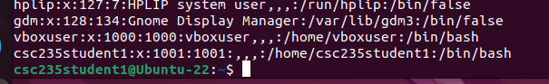

**Part 2: instructions to reset a password**

Step 1: Boot into recovery mode

If you’re using Oracle VirtualBox or VMware, you have to hold down the shift key when the logo of Oracle or VMware appears. Keep holding it down until the screen below appears.

If you have a Linux OS only (not running on a VM), then switch the computer on Go to the grub menu. Generally, it appears automatically – if not, then hold down the shift key or press Esc key until the boot menu appears

This is the Grub menu: select “**Advanced Options for Ubuntu**”

Then, choose “**recovery mode**”

Step 2: Drop to root shell prompt

Step 3: Reset the forgotten user password

Once you have the command prompt, change the password for the affected username.

Type passwd *username*

When complete, return to the normal boot by typing exit and then select “**Resume normal boot**”.

Task: boot to recovery mode and change the password for the affected user. Capture your actions with a screenshot like the example above.

**Screenshot:**

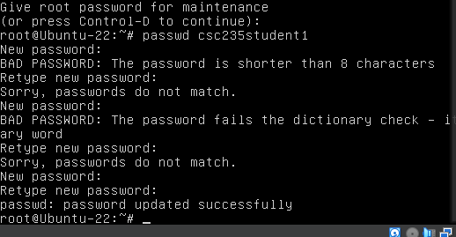

*\* The following screenshots show that I was now able to log in to the user account with the updated password!*

**Part 3: delete unneeded user accounts**

Use the following command to list all the users available:

ls /home

You can delete a user with the deluser command. As shown above, I did not need the user account tonystark, so I deleted it using deluser *username* (note the need for sudo).

Task: remove a user. Capture a screenshot that shows the user account to be deleted. Then, create a screenshot that shows the successful removal of the account (see the example above).

**Screenshot (pre-removal):**

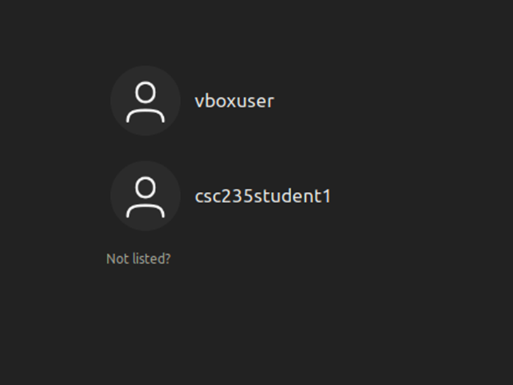

**Screenshot (showing the removal of the account):**

